COVID-19 Really set you back. You wonder every day -
"How can I hold it all together?" Help is here.
You may qualify for the New York State Emergency Rental Assistance Program
The Emergency Rental Assistance Program (ERAP) assists households behind on their rent that have experienced financial hardship due to COVID-19 and are at risk of homelessness or housing instability. In addition, the program can provide temporary rental assistance and assistance with unpaid utility bills.
Eligible residents must meet the following criteria:
- Household gross income at or below 80 percent of area median income, which varies by county and household size.
- A member of the household received unemployment benefits or experienced a reduction in income, incurred significant costs or experienced financial hardship, directly or indirectly, due to the COVID-19 pandemic.
- The applicant owes past due rent at their current residence.

This assistance can pay up to 12 months of past due rent and for some households, pay up to 3 months for future rent. The program can also pay for up to 12 months of overdue electric or gas bills. Please note, payments will always be issued directly to the landlord or utility provider.

Applications can be submitted online at nysrenthelp.otda.ny.gov.
[Insert logo and contact info here]

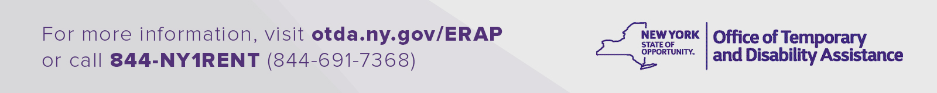
(Rev. 08/21)

